Racism in the USA
BY: BASHEER AHMED SOURCE: ISLAMICITY JUN 16, 2020
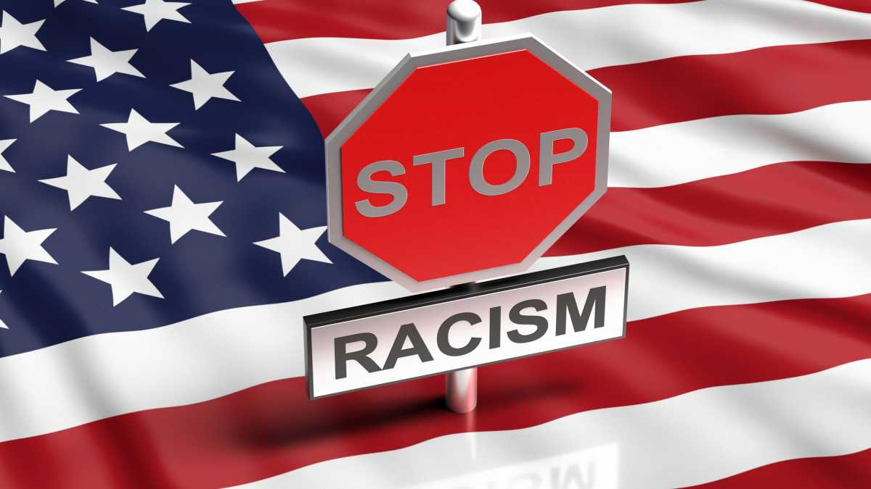
Stop racism sign on American union flag background (photo: iStock by Getty Images).
https://www.islamicity.org/50029/racism-in-the-usa/
"Ican't breathe." "I can't breathe." These were George Floyd's last words, but they didn't die with him. They will continue to reverberate until we bring a change. As Gianna Floyd, George's six-year-old daughter, said, "My daddy changed the world". A child spoke these words to a nation where too often just the color of your skin puts your life at risk. Many whites are outraged with the current situation. However, if most white people decided that racist policies should end, we'd start seeing changes in police attitude towards African Americans.
Our hearts go out to the family of George Floyd and to those in the U.S. who continue to experience systematic police brutality that often targets our African American brothers and sisters. Our hearts hurt for our black brothers and sisters who live the daily reality of systemic injustice and racism in our country.
Since the murder of Mr. Floyd, we have heard numerous speeches and read thousands of articles about racism in the USA. North America has a horrific 400 years history of slavery and genocide. Formal aspects of slavery ended with the Civil War, during which hundreds of thousands of white and black soldiers lost their lives. Abraham Lincoln emancipated the slaves but not the idea of slavery from white Americans. Unfortunately, while law abolished, lynching, and segregation, they continue today in one form or another. After the Civil Rights Act, most white New Yorkers believed that the civil rights movement had gone too far. Many white liberals felt embarrassed, at the images of cruelty, rather than the idea of genuine, equitable inclusion. As Joe Biden put it, "The original sin of slavery stains our country today."
Some good laws came into effect, but the racial mindset continued, and now police atrocities, particularly against black people, have become commonplace. The presence of video cameras recently made Americans aware of the gross injustices against people of color, but what is the point in having evidence when there is no action taken from many in white America.
Rodney King, Rakia Boyd, Eric Garner, Quan McDonald, Tamir Rice, Walter Scott, Mike Brown, Travon Martin, Freddie Gray, Sandra Bland, Botham Jean, Alton Sterling, Philando Castile, Atatiana Jefferson Ahmaud Arbery, Breonna Taylor, David McAtee, and George Floyd are just a few names out of hundreds of African-Americans. There are countless others whose names do not make the news or ever enter our minds, but whose stories matter and whose lives were significant.
President Jimmy released a statement "In 1971, inaugural address as Georgia's governor, I said, "The time for racial discrimination is over." With great sorrow and disappointment, I repeat those words today, nearly five decades later. People of power, privilege, and moral conscience must stand up and say "no more" to a racially discriminatory police and justice system".
At the funeral of Mr. Floyd, Reverend Al Sharpton made a passionate speech describing the oppression experienced by racism. 'Get Your Knee Off Our Necks,' Sharpton says, "In the past 401 years, the reason we could never be who we wanted and dreamed of being is you kept your knee on our neck. We were smarter than the underfunded schools you put us in, but you had your knee on our neck. We could run corporations and not hustle in the street, but you had your knee on our neck. We had creative skills, we could do whatever anybody else could do, but we couldn't get your knee off our neck. What happened to Floyd happens every day in this country: education and health services, and every aspect of American life. It's time for us to stand up in George's name and say, "Get your knee of our necks."
Social protests have been a means to put collective pressure on lawmakers and society all over the world. The purpose of the demonstration is to raise public awareness about a legitimate frustration over a decades-long failure to reform police practices and the criminal justice system in the United States. Institutional racism is a threat to our community, and it manifests itself in police violence, police indifference, and dehumanization.
Unfortunately, the current protests have spiraled beyond peaceful demonstrations into violent riots across the country. It has resulted in putting innocent people at risk, and the destruction of neighborhoods, detracting from the larger cause. We support peaceful protests asking for an end to racism and violence in all forms. We hold our law enforcement agencies to the highest form of professionalism and self-restraint while acknowledging their dangerous and challenging job to uphold the law.
Despite the progress we have made in the last five decades to bring racial equality and harmony to the U.S., we still see that black youth are over five times as likely to be detained compared to white youth. Black Americans are shot and killed by the police at a much higher rate than white Americans. Black Americans have been disproportionately impacted and account for more than half of all COVID-19 cases and almost 60 percent of deaths, even though Black Americans represent only 15 percent of the population. Ongoing racism-related experiences in life also contribute to chronic mental health issues due to despair and hopelessness in the African American community. The current Administration is not making any effort to improve the situation.
Our President unfortunately inflamed the situation by encouraging violence against protestors. He has failed to address the racial inequalities in our healthcare system that have worsened the coronavirus crisis for black communities. He has not mourned with families and communities who have lost loved ones to racially charged police violence in the past – or mourned with our nation for the killing of George Floyd. Instead, he used tear gas to disperse peaceful protesters so he could stage a photo op.
The Episcopal bishop of Washington, D.C. Mariann Budde, stated that everything the President has said and done is to inflame violence. We need moral leadership, and he's done everything to divide us, and has just used one of the most sacred symbols of the Judeo-Christian tradition.
Mr. James Mattis, former defense secretary in the Trump administration, writes, that the protesters are rightly demanding 'Equal Justice Under Law'. It is a wholesome and unifying demand—one that all of us should be able to get behind. Initially, Defense Secretary Mark T. Esper and General Mark A. Milley, the chairman of the Joint Chiefs of Staff, publicly aligned themselves behind a president who chose tear gas and rubber bullets to clear peaceful protesters from a park. However, Gen. Martin E. Dempsey, a former chairman of the Joint Chiefs of Staff, stated, "America is not a battleground, the fellow citizens are not the enemy." The next day defense Secretary Mark T. Esper broke with President Trump and said that the Administration should not deploy active-duty military troops to control the wave of protests in American cities.
God says in the Holy Quran: "O you humankind, inevitably We created you of a male and a female, and We have made you races and tribes that you may get mutually acquainted. Undoubtedly the most honorable among you in the Providence of Allah are the most pious." (49:13)
The Quran also states, "O you, who have believed, be persistently standing firm in justice, witnesses for Allah, even if it be against yourselves or parents and relatives." (4:135)
Prophet Muhammad (PBUH), taught us to recognize, expose, and reject racism. He said: "None of you fully believes until you love for your fellow (human) brother/sister what you love for yourself". Some companions of Prophet Muhammed asked him to keep Hazrat Bilal - the freed black slave out of the meeting. The Prophet was committed to building cohesive societies and did not believe in exclusion, and he assigned Bilal an honor to call on the prayer (Adhan).
It is often that white people write off incidences of police brutality as actions of a few twisted, racist, or particularly sadistic individuals. For Black people, police brutality, misconduct is a daily experience. The cause is not an individual phenomenon, but it is a symptom of a disgraceful white supremacy system. After 400 years of this fixed thinking, it appears to become a genetically determined pattern of thought and behavior. There is no recognition, and there is a silence in the face of traumatic experiences that exacerbate the black community's suffering for generations upon generations.
In the words of Dr. Martin Luther King Jr., "The ultimate tragedy is not the oppression and cruelty by the bad people but the silence over that, by the good people". It is time that we break this silence and speak up.
We condemn and denounce racism and injustice. It is against the teaching of Islam and the fundamental rights of human beings. We join with the community to work together to construct healthier communities through compassion, tolerance, and service. We all wish to live in a world having no injustice and a world with opportunities for anyone. We pray that we see an end to the violence, hate, and racism directed towards our black community.
Dr. Basheer Ahmed is the former professor of psychiatry, South Western Medical School, Dallas, Texas, and chairman emeritus MCC for Human services North Texas. He can be reached at mbahmed05@yahoo.com

