The Spirit of Fasting in the month of Ramadan
As the countdown to Islam’s holiest month begins Dr. Basheer Ahmed takes us through its essence and significance
M. Basheer Ahmed M.D.
Mar 20, 2023 04:01 PM CDT
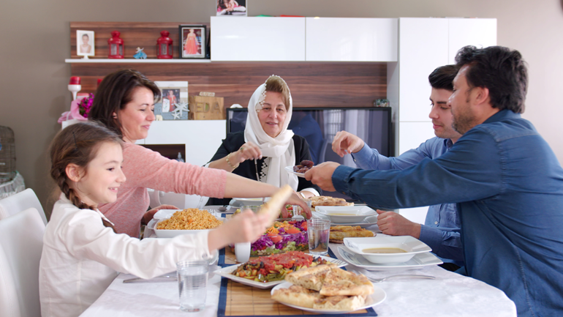
The month of Ramadan is indeed an exceptional time for Muslims around the world. It is the ninth month of the Islamic lunar calendar, during which Muslims fast (refrain from eating and drinking) from dawn until sunset. The fast is observed as a form of worship and is one of the Five Pillars of Islam.

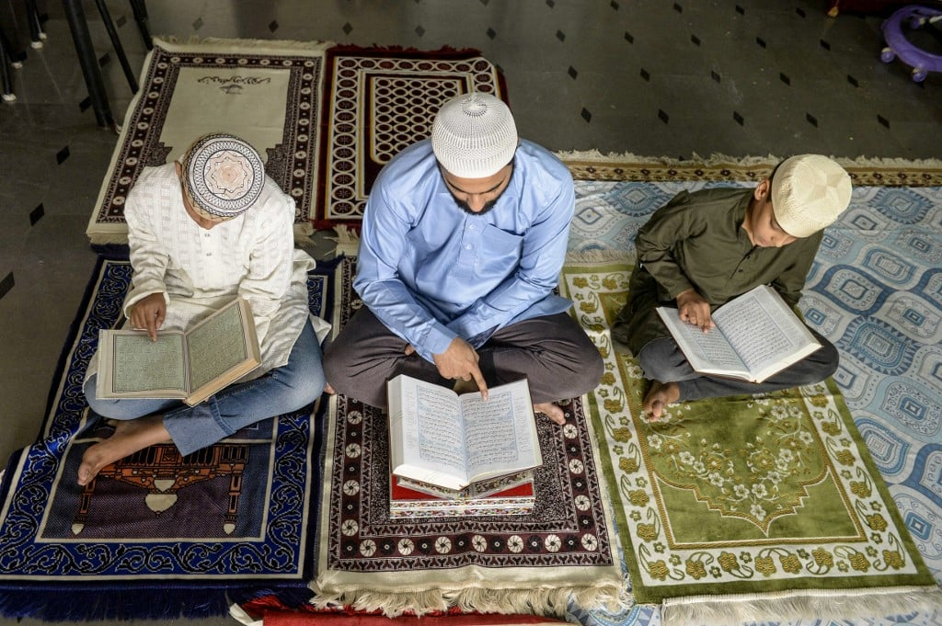The blessed month of Ramadan (fasting) starts this year on March 23 and ends on April 21, 2023. It’s the month when the Quran, the holy book of Islam, was revealed to Prophet Mohammad (PBUH)) in 610 AD.

It is an act of worship that helps Muslims feel closer to Allah and strengthens their faith. It also helps to cleanse the soul by resisting temptation and avoiding behavior considered sinful. They do this additionally through praying, reciting the Quran, making their actions purposeful and selfless, as well as refraining from such sins as lying, gossiping, and fighting, to reach peace and tranquility.

During my childhood, the excitement we experienced sighting a new moon at the beginning of the month of fasting-Ramadan was intense. Adults and children look forward to tarweeh prayers at night in the Masjid, socializing with family and friends, and celebrating the major Eid festival at the end of the month of Ramadan.

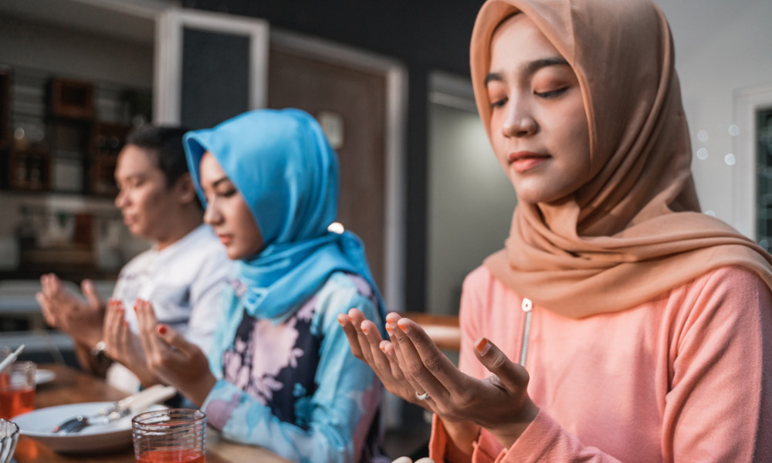God says in the Quran “You who believe! Fasting is prescribed to you as it was prescribed to those before you, so that you may attain Taqwa.” (2:183) Taqwa (restraining oneself from bad behavior) simply means to protect oneself from the Anger of Allah (swt) and His Punishment. The Muttaqun are those who believe in Allah and are involved in the affairs of humanity and avoid God’s displeasure.

The Islamic faith is composed of unique rituals to bring discipline to human life. Fasting is one of the five key rituals that Muslims around the world observe. The essence of fasting is to become humble, simple, and free from ill will, anger, meanness and hatred, avoiding actions designed to hurt the feelings of others from dawn to dusk, every day for a month.

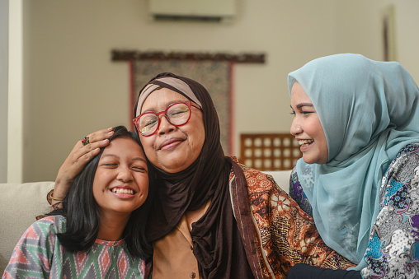Habits are notoriously difficult to change, especially ingrained ones. But fasting gives us confidence that we can change our set ways and especially our bad habits. True fasting is self-purification, which leads to the development of human values such as generosity, patience, kindness, forgiveness, mercy, justice, and empathy - these are necessary for the success of self and society.

One of the purposes of religion is to develop the highest moral standards and through fasting, we can attain piety and purification of self. During the state of fasting, one experiences hunger and thirst. It teaches Muslims to be more empathetic towards those who are less fortunate and appreciate the blessings that they have in their lives by developing a sense of mercy for those who are less fortunate.

Ramadan is also a time to share one’s wealth with the needy- in the form of charity called Zakat, the fourth pillar of Islam. It’s a religious duty that every Muslim family takes out 2.5 percent of the value of their assets and passes it on to those in need, deserving family members, fellow Muslims and non-Muslims.

The Prophet said, "If one slanders you or aggresses against you, say I am fasting." This is the best way to control your anger and negative emotions. He also said: “There are so many of fasting people who do not get anything out of fasting except thirst and hunger. These are the people who fast but do not refrain from bad behavior. He also said “God has no need for the hunger or thirst of someone who hurts others, violates their dignity or usurps their rights.”

We now know there are multiple potential physical and medical benefits to fasting, such as a reduction in calorie intake, which can lead to weight loss. Studies have shown it to improve insulin sensitivity, which can help with blood sugar control. Some research has shown that fasting can help lower blood pressure, reducing the risk of cardiovascular disease.

Fasting has been associated with improved immunity and a reduction in inflammation, which is linked to several chronic diseases such as arthritis, cancer, and heart disease. Some experts have suggested that fasting can improve cognitive function and may even reduce the risk of neurodegenerative diseases such as Alzheimer’s. It’s important to note its physical benefits may vary depending on the individual and the type of fasting, so it should always be done under the guidance of a healthcare professional.

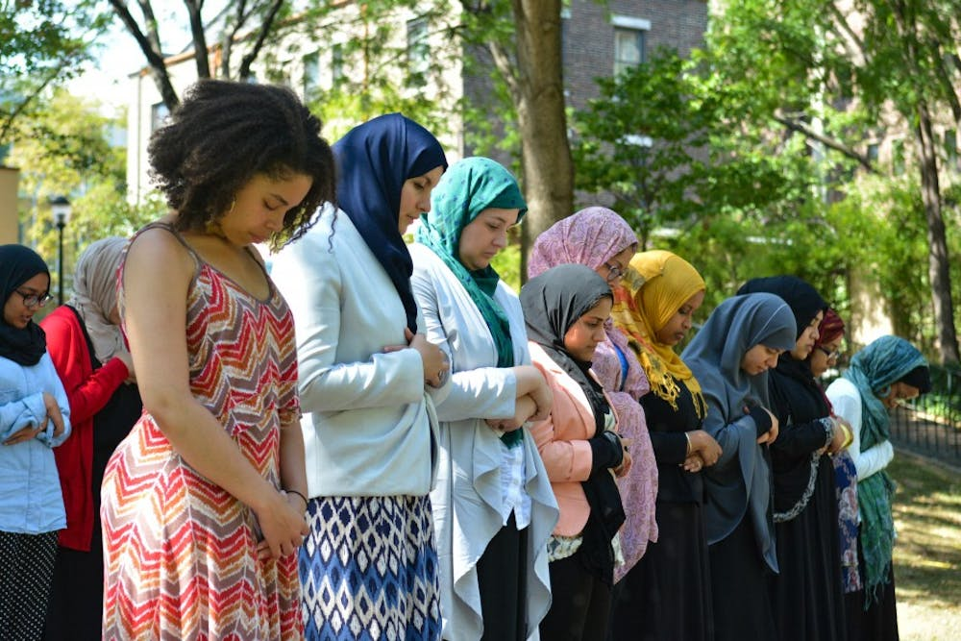

For those of the faith, it's critical that this month doesn't become a mere ritual, where fasts are opened with excessive food at night or overindulgence. God says in the Quran “It is not righteousness that you turn your faces towards east or west, but it is righteousness - to believe in Allah and the Last Day, and the Angels, and the Book, and the Messengers; to spend wealth, out of love for Him, for your kin, for orphans, for the needy, for the wayfarer, for those who ask, and for setting the slaves free; to establish prayer, and practice regular charity; to fulfill the contracts which you have made; and to be firm and patient in tribulation and adversity, and in times of panic (or stress). Such are the people of truth and they are al-Muttaqun,” (2:177).

Ramadan brings Muslims together as a community, creating a sense of unity and brotherhood as Muslims come together to worship and share meals. For fasting to be truly universal, it should promote a sense of what it means to be truly human, and its universality is reflected by extending the cordial relationship to Muslims of all sects and people of all faiths.

In the Quran, Al-Hujra, Surah 49:13 says: "O mankind! We have created you male and female and have made you nations and tribes that ye may know one another. The noblest of you, in sight of Allah, is the best in conduct. Allah Knows and is Aware."

Overall, fasting during Ramadan is a time for self-reflection, purification, and spiritual growth that can have a profound impact on a Muslim's faith and life.

Dr. Ahmed is the former Professor of Psychiatry at Southwestern Medical School, chairman emeritus MCC for Human Services, and president, the Institute of Medieval and Post Medieval studies. He can be reached at mbahmed05@yahoo.com.

Facebook Twitter Instagram

