Status of the Muslim Umma
BY: BASHEER AHMED SOURCE: ISLAMICITY JUN 6, 2020
https://www.islamicity.org/47803/state-of-the-muslim-umma/
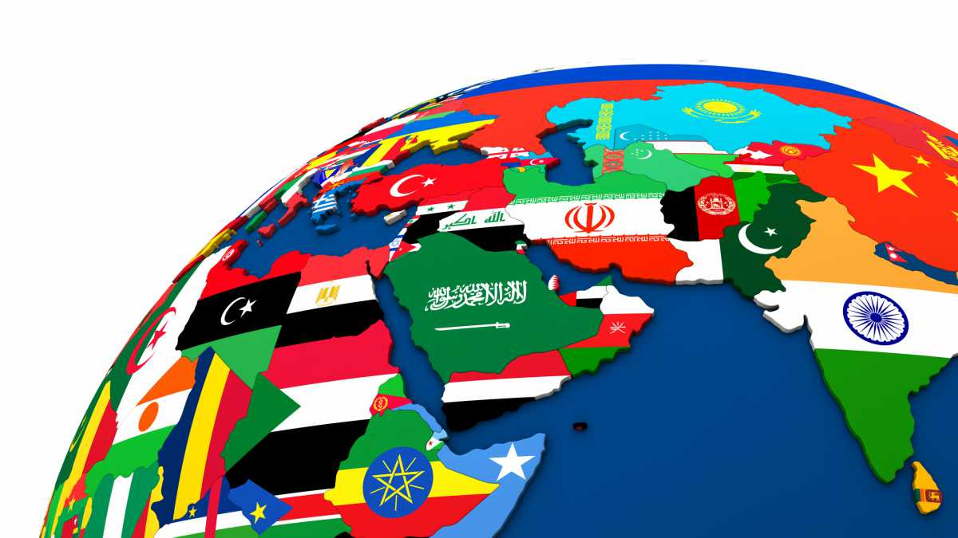
Political map of Middle East with each country divided and represented by its national flag (photo: iStock by Getty Images).

What have we learned from history? Quran shows clear guidelines for solution.
What is happening to Muslims worldwide is a matter of grave concern for every advocate of human rights. Uyghur Muslims are in concentration camps for believing in their faith. Hundreds and thousands of Rohingya Muslin refugees from in Myanmar are seeking shelter in neighboring Bangladesh, which cannot support them. In Kashmir, Indian forces have brutalized Muslims for standing up for their rights. In India, the extremists killed thousands of Muslims and destroyed properties worth millions for opposing discrimination against them. Under the new extremists' regime in India, Muslims live like second class citizens. Most of them are poor, illiterate, and face violence and terror daily. Palestinians 70 years struggle for freedom and an independent state after losing almost 70 percent of their land is a never-ending story of oppression in our world. The Jewish state is forcing them out of their homes and is building new settlements, forcing the natives to live an extremely miserable life. Muslims in Europe and the United States face Islamophobes every day.
The fate of Muslims in their homeland is not particularly rosier. From one end of the Muslim world to the next, Muslims - in Iran, Syria, Egypt, and Saudi Arabia - live under brutal regimes, ruthless kings and dictators, with limited civil liberties and Human rights.
Two major factors contribute to the prevailing pathetic dismal condition of Muslims worldwide: Lack of education and lack of unity.
The Gulf Countries have trillions of dollars from oil revenues, a financial bonanza, a great gift, and a blessing from God. Proper utilization of this wealth can create educational institutions and industries all over the Muslim world that may help eliminate illiteracy and poverty and make the Muslim Umma, once again, a vibrant community in the world.
Unfortunately, the Muslim Umma has divisions in the name of sects, such as Shia, Sunni, Ismaili, Bhoras, Ahmadiyya, Deobandi, Barelvi, Salafi, Wahabis, Ahle Sunnat, Ahl Quran, and Sufis just to name a few. The scholars are busy declaring anyone who does not agree with their interpretation of Islam as a deviant. Some go to the extent of saying their opponents as Blasphemers.
They tell the world that Islam is a religion of peace and tolerance; however, they do not practice what they teach. The nobility of a human being depends on one's actions, and Allah is the only one who can judge the loyalty and nobility of a human being. According to the Quran, all human beings are from the same soul, but they have differences. The Quran says: "O humankind, we (God) have created you male and female, and made you into communities and tribes so that you may know one another. Surely, the noblest among you in the sight of God is the most God-fearing of you; God is all-knowing and all-aware" (49:13).
Unfortunately, not many Muslims follow these Quranic commandments.
During the last 30-40 years, we have seen a marked increase in sectarian violence. It is common to hear that Muslims (Shias and Sunnis) planting the bombs in Masjids on Fridays, the most sacred day for Muslims, and or planting bombs in shrines killing scores of innocent people. It confirms extremist behavior, and if this behavior continues, this will cause serious damage to Muslim Umma. We must stop the massacre of Muslims by Muslims so that Muslims can be united to face the biggest terror from Islamophobes and anti- Muslim organizations which are trying to annihilate Muslims. There is no doubt that the Christians Jews, Hindus, and others are committing the atrocities against Muslims. However, we can cope and find better ways to deal with these issues if we stand united.
The atrocities committed by Muslim groups are harrowing and intolerable. By blaming each other or blaming a conspiracy or foreign influences are not going to alleviate the problems. It is our responsibility to avert this situation before it escalates any further. Allah says in the Quran: "As to those who split up their religion and become sects, have you nothing to do with them; their affair is with God. Hereafter shall He tell them what they have been? (6:159)
"Yet they divided themselves into factions, each rejecting in what they had. So, leave them in their bewilderment for a while." (23:53-54)
The majority of Muslims condemn violence, but unfortunately, but not many are willing to challenge the fanatics who are promoting these behaviors. It requires a lot of courage and stamina to get out and face this challenge.
In the nineteenth century, as the Ottoman Empire was losing its power, Muslim countries were colonized by Western powers: Algeria and Tunisia by France, Libya by Italy, and Oman, Kuwait, Egypt, Sudan, and Yemen by Britain. The Sykes-Picot agreement of 1916 divided the remaining parts of the Empire. At the end of World War I, with the defeat of Germany, and the Ottoman Empire, France took over Lebanon and Syria, and Britain took control of Iraq, Kuwait, Jordan, and Palestine. Most of the Muslim world from the Middle East to the Far East was under European control. In 1932, the kingdom of Saudi Arabia came into existence with the help of the British government. In 1943, the Saudis signed a defense contract with the United States, which established its first military base at Dhahran in 1945. Saudi Arabia depends on the U.S. for its defenses.
However, after the Second World War in 2 decades, most of the Muslim countries threw off the yoke of colonialism. The discovery of oil improved the financial status of the Gulf countries. A complex sequence of events revolved around that time and Muslim countries experienced political and social transformation and turmoil.
Some key factors shaped the Middle East as we know it today.
The decline in the status and power of Muslim Umma is a global phenomenon.
At the instigation of the U.S. and Saudis, Saddam started the war with Iran, resulting in the loss of life of a couple of millions of people and billions of dollars in 2 rich Muslim countries, making U.S. and Russia richer for sales of their arms. The entire Muslin world watched the destruction where both countries achieved nothing.
In the 1990s, a few years after the end of the Iran-Iraq War, neoconservative politicians developed plans for the U.S. to regain access to the oil reserves in several Middle Eastern countries, including Iraq and Libya and to make them powerless. With the 9/11 attack on the Twin Towers as justification, a US-led coalition invaded Iraq in 2003. According to the Chilcot report published in Britain in July 2016, the illegal Iraq War got off on false information that Iraq had hidden weapons of mass destruction. Saddam Hussein did not pose a threat to British interests, the report concluded. Unfortunately, the prolonged Iraq War resulted in giving birth to the terrorist organization ISIS, which declared sovereignty in part of Iraq and Syria (that ended in 2017).
The war brought more death and mayhem in the Muslim world than have all the terrorists (including ISIS) and militant groups combined. Hundreds of thousands of innocent Iraqi men, women, and children lost their lives. Today, American oil companies, once again, have control of Iraqi oil.
Saudi Arabia and the U.S. succeeded in isolating Saddam Hussein while the entire Muslim world watched the destruction of Iraq silently. They also encouraged sectarian violence that has yet to cease. More than a million Iraqis lost their lives with only a few thousand U.S. casualties and now sectarian hatred and violence rule of the country. Libya, one of the progressive countries, was the next target. The Muslim world watched its destruction quietly. Now there is anarchy in Libya. Where is the Muslin power? It is lost not by conspiracy but sheer foolishness and self-interest.
Once again, Syria is experiencing the same scenario. Now the western powers know that they do not have to waste their soldier's lives and do not have to spend their wealth. They spend minimum resources to promote sectarian violence, sell arms to Saudis, who supply the weapons to terrorist groups to fight against Syrian Govt. forces. Bashar al-Assad (and his Russian and Iranian backers) is responsible for the slaughter of thousands of Syrians. The result was the destruction of a stable country, with millions of Muslim refugees (the worst humanitarian crises in human history), and the loss of hundreds of thousands of Muslim lives. Turkey's war with the Kurds amounts to even more Muslims murdering Muslims. Egypt and Iran, too, continue to maim and kill their citizens in prisons or the streets. According to United Nations, Saudi Arabia, the United Arab Emirates, and seven other Arab states in their coalition, the government, and the rebel forces in Yemen—may have committed war crimes in the bloody Yemeni civil war. Since the beginning of the conflict in Yemen, an estimated 85,000 children under five have died from extreme hunger and diseases, 14 million people are at risk of famine, 3 million are refugees, and 15 million men, women, and children have no access to health care.
Iran is next in line, and the U.S. and Israel are already preparing to destroy Iran with the support of Saudis and Gulf countries. Saudi Arabia does not realize that after the destruction of Iran, the Gulf will have no option but to surrender its sovereignty to others.
In Pakistan, religious seminaries are everywhere. They recruit thousands of young children from poor families and provide them with free boarding and lodging (a good humanitarian work). They indoctrinate them with fanatic ideas, promoting the khilafat all over the world and killing people with a creed different from them, calling them (Kafir and Mushrik). Many in these seminaries learn that killings of kafir and mushrik will purify the land.
It is time that we must acknowledge the presence of fanatic behavior among Muslims. These violent practices are contrary to the actual teachings of Islam. Publicly it is impossible to equate Islam with peace when the very countries that are supposedly practicing Islam have this level of violence.
The majority of the Muslims (over 90%) do not subscribe to the sectarian violence. But, by keeping quiet, we are silently supporting the activities of those who indulge in violence. After each Terrorist attack, Muslim organizations and groups issue press releases condemning it and even claiming that the perpetrators are not Muslims. But there is no effect of these press releases except showing that we are against it. Two major international conferences took place in Jordon and Dubai attended by Ulamas of Shia and Sunni sects. They also ended in issuing big press releases with no significant influence on governments or ordinary people. Global Terrorism and sectarian violence by Muslims continues.
Today Islam is portrayed not as a religion of peace but as a religion of violence and Terrorism.
Boko Haram abducted 300 girls, Pakistani Taliban killed 140 children in addition to 70 more in Lahore. Al Shahab, Jaish Muhammad, and Lashkar Taiba, through their activities, bring ill fame to Islam.
Quran Says, "If a man kills a believer intentionally, his recompense is Hell, to abide therein (for ever): And the wrath and the curse of Allah are upon him, and a dreadful penalty waits for him." (4:93)
The rising of Islam phobia and its effect on minority Muslims in Western countries are serious issues. We need to remember that if we do not take care of Minorities in Muslim Majority countries, why anyone should care for Muslim Minorities in the Western countries. There is a saying that "Treat Others how you want others to treat you."
Young Muslims today are confused by the different "brands" of Islam practiced today. In Islam, the essential building blocks of faith or Aqidah, comprise of belief in one omnipotent God who is a sustainer of life and also in angels, revealed books, prophets, and Day of Judgment. Beyond this essential foundation, the practice of religion has many variations in Shia, Sunni, and schools of thought (Hanafi, Maliki, Shafi'i, and Hanbali). Practicing any one sect or religious school of thought or none should be acceptable. Getting into intricacies must be considered divisive and, therefore, counter-productive to harmonious Intra-faith relationship. If you have strong faith, diversity in religious practice must be accepted as based on human understanding and should not be the cause of anger, hatred, and violence.
It is impossible to have an entire community of 1.6 billion to think alike on all issues, but it is possible to coexist with the people of different beliefs. The major challenge is to pursue people to stop killing one another because they have different interpretations of the Quran or events in history that took place 1,500 years ago.
Today, young Muslims are learning more about Islam from Media, and unfortunately, our Imams and Muslim scholars are not addressing the issue of sectarianism and violence. The silence of community leaders on the dangers of bigotry and resulting death and destruction, as in our back-homes, should be our common cause of concern.
We should not wait until our youth become fanatics. We must ignore political events, which led to conflicts. We must teach our children to follow the teachings of the Quran and Prophet Muhammad (PBUH) by showing respect and dignity towards everybody and avoiding hatred and anger humiliation towards followers of any faith or creed, which may lead to discrimination suffering or killing of innocent people. It becomes complicated for the many Muslims to reach out to the illiterate and superstitious Muslims in the Muslim majority countries especially when the well-organized Madrasas ingrained the young mind for 10-15 years with orthodox teachings with primary emphasis on rituals and with unshakeable beliefs in creeds which cannot be subjected to logical thinking. Many Muslims who wanted to bring this knowledge are not well organized and do not have a central leadership.
In North Texas, a group of Muslim community leaders developed an organization, the Institute of Quranic Knowledge and Religious Acceptance (IQRA).
We started dialogues with community leaders of the Islamic faith, irrespective of their being Sunni or Shia or any other minority sect. The purpose of these dialogues is not theological debate; instead, it is a discussion of how, as leaders, we can tell our followers that violence between the sects is counter-productive for all involved. We plan to protect future American Muslim generations from the scourge of sectarianism by practicing Islamic teachings of peace and tolerance of all faiths.
IQRA is the first organization of its kind in the Dallas–Fort Worth area and perhaps in the entire country. It has the vision to promote unity at the grassroots level among all peace-loving Muslims.
We reached out to all the imams (Muslim religious leaders) in the Dallas–Fort Worth community. We invited them to come together to discuss the ideas to develop a harmonious relationship. Some imams didn't respond, others weren't interested, but many more attended and supported the concept for the Institute to promote nonsectarian, religious feelings among our children so they wouldn't grow up filled with hate and anger. We have since held many intra-faith events.
The purpose of these community interactions is to share concerns and develop proactive strategies for building bonds of trust and positive partnership to safeguard peace and tranquility. IQRA follows Quranic guidelines.
Quran says “And We have revealed to you, [O Muhammad], the Book in truth, confirming that which preceded it of the Scripture and as a criterion over it. So, judge between them by what Allah has revealed and do not follow their inclinations away from what has come to you of the truth. To each of you We prescribed a law and a method. Had Allah willed, He would have made you one nation [united in religion], but [He intended] to test you in what He has given you; so race to [all that is] good. To Allah is your return all together, and He will [then] inform you concerning that over which you used to differ” (Quran 5:48).
God has sent down the Book Qur’an as a truth, confirming the Scriptures that came before it. These Books confirm and do not contradict one another and show that they are all different versions of one and the same message. Allah prescribed different regulations to suit different communities in different times. No doubt Allah could have prescribed one and the same Law for all human beings, but He did not do so to test people whether they obey or not what is given to them by Allah. As the real object of all the laws is the cultivation of virtues, Allah has commanded the people to excel one another in virtues, without paying heed to the apparent differences in different rituals, rulings and interpretations. As regards the differences, they cannot be resolved by arguments or war. Allah will decide the truth on the day of Judgment.
Although the verse discussed the books revealed to previous generations which has created conflicts. Same thing happened to Muslims who developed conflicts due to different interpretations and different understandings of Quran.
If you believe your faith and Aqidas is correct. Follow it with full trust and Iman on it. Remember everybody believes in their Faith and Aqidas as you do. When we return to God, He will decide who is right or wrong. You do not humiliate, insult, denigrate any faith or Aqidas. It needs to be pointed here that 75% of people of the world do not agree with Islamic faith and Aqidas, while we Muslims strongly believe that this the only
feelings towards people whose faith or Aqidas are different than yours. The decision about salvation will be made by God based on your virtuous behavior. Those who choose good behaviors of kindness, morality, and serving humanity will be rewarded. Therefore, we need to compete in doing good behavior to achieve God’s Favor. Allah (swt) purposely created a diverse community in the world and gave intelligence and power to each one of us to choose the righteous behavior not to be preoccupied in proving who is right or wrong.
Dr. Basheer Ahmed is the former professor of psychiatry, South Western Medical School, Dallas, Texas, and chairman emeritus MCC for Human services North Texas He can be reached at mbahmed05@yahoo.com.

