Marking Muharram and The Courageous Woman in the Story of KARBALA

M.Basheer Ahmed M.D.
Jul 28, 2023 02:57 PM CDT
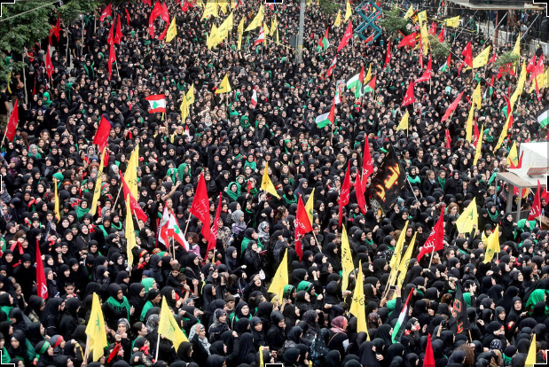

It was a battle between good and evil. Imam Hussain, the beloved grandson of Prophet Muhammed (peace be upon him), stood up against Yazid, whose father, Amir Muawiya, made him a successor caliph. Yazid was considered impious and unworthy of being Khalifah and therefore Hussain refused to recognize or endorse his leadership over the rapidly growing Muslim Ummah and Muslim state.
On this day (July 28^{th,} 2023), 1400 years ago, a large force of Yazid martyred and mutilated the bodies of Imam Hussain and 72 of his followers at the famed Battle of Karbala, in modern-day Iraq. They captured and enslaved surviving women and children, taking them on a harsh journey of over 400 miles to Damascus.
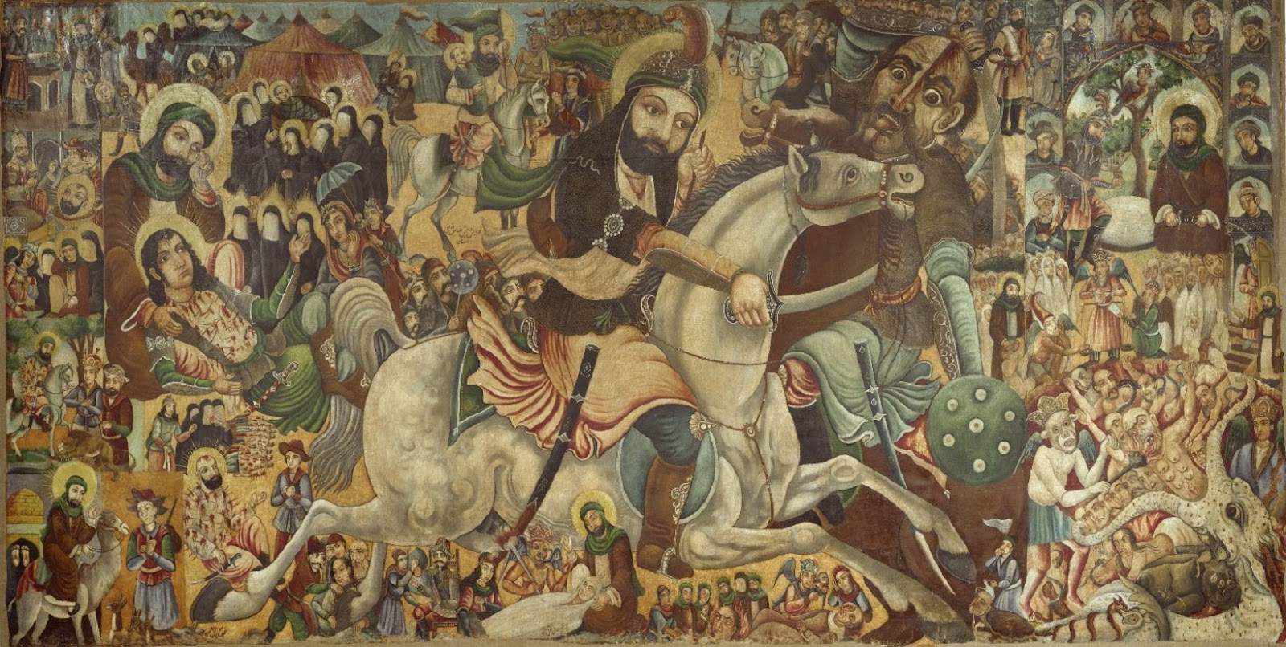

Muslims worldwide commemorate this tragic event in 680 AD, the day of Ashura occurs on the 10th of Muharram, the first month of the Islamic calendar. This month is special as one of the four sacred months of the Islamic lunar calendar.
This was when Prophet Muhammed migrated from Makkah to Medina to build a new society based on justice. It also marks the day of salvation for Moses and the Israelites, who successfully escaped enslavement and persecution in Egypt, after the parting of the Red Sea.
The Prophet said, "I am closer to Moses than Jews." So, he observed the fast (on that day), and Muslims followed this tradition while many simultaneously fast to experience the suffering of Imam Hussain and his family, who were martyred in Karbala by Yazid's army.
The story of Karbala began when Hussain refused to pledge allegiance to Yazid. The Umayyad Caliphate was a dynasty renowned for desecrating human dignity, freedom and justice and this corruption, inequality and immorality directly contradicted the teachings of Hussain’s grandfather, Islam’s founding prophet.
Imam Hussain had traveled to Kufa at the invitation of the local Muslim community. However, when he reached nearby Karbala, the locals were too afraid to meet him, fearful of Yazid's brutal army. Hussain courageously chose to stay and this led to a ten-day standoff, between Umayyad's considerable forces and a few of Imam Hussain's followers, which included his half-brother, wives, children, sisters, and closest friends.
While his erstwhile supporters betrayed him, Hussain’s family stood by him. All knew the chances were high they may not survive at the end of any conflict. They stood for righteousness and justice and sacrificed their lives for Islam and such valor in the face of the ensuing brutal massacre is rightly a legacy of their lives.
We should also remember the bravery of Hazrat Bibi Zainab, the younger sister of Hussain. At Karbala she publicly rebuked Yazid and his followers without showing any fear even after witnessing the slaughter of her brother and her two teenage children. It was a shining example of defiance against the power of a tyrant.
Zainab is also revered for saving Hazrat Zain al-Abidin, a surviving son of Hussain, as well as Bibi Sakina, Hussain’s daughter from enslavement. After her release and return to Madina, she continued to spread the mission of Hussain and to raise her voice against oppression.
Today, while Muslims from different sects and denominations commemorate the martyrdom of Imam Hussain, Shia Muslims, often express their grief with more intensity. They hold daily ceremonials (Majlis) and narrate the events that led to Shahadat (martyrdom). It could be argued the lessons from Karbala are relevant the world over.
We know from modern history what happens when human beings fail to stand up against corruption and evil ideologies. We can even equate the people of Kufa to German society in the 30’s and 40’s whose silence and complicity in Adolph Hitler’s rise to power led to the massacre of six million Jews.
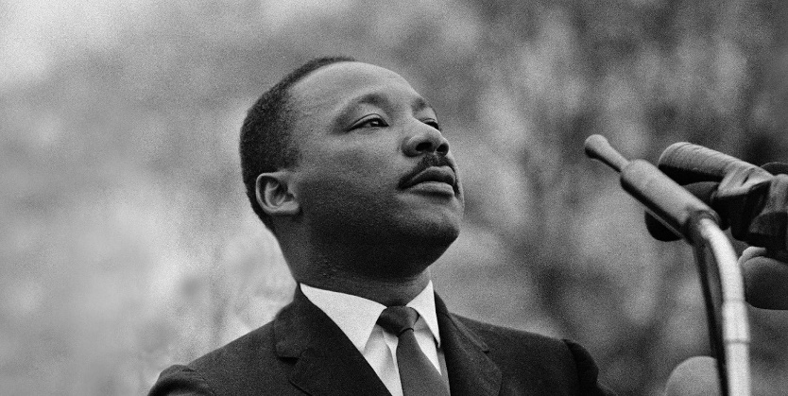

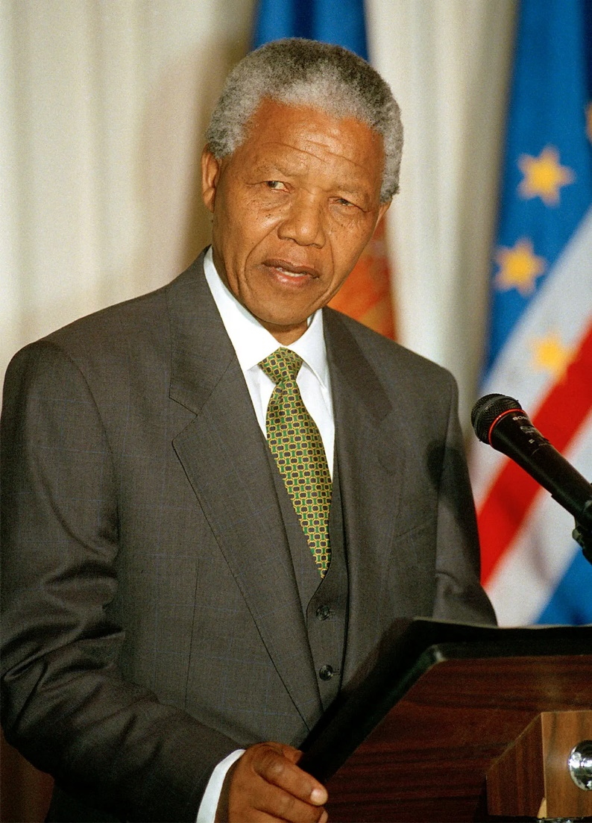
While too many leaders rule Muslim majority countries in oppressive dictatorships and few have followed in the haloed steps of Imam Hussain, elsewhere there are historical leaders who have emulated his courage and philosophy using peaceful means. Icons such as Martin Luther King who fought the evil of segregation and poverty and South Africa’s Nelson Mandela who opposed apartheid, come to mind.

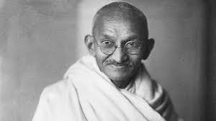
Indian civil rights leader, Mahatma Gandhi, pays direct tribute to Imam Hussain, "If I had 72 companions like Hussain, I would have freed India in 24 hours from the British; the progress of Islam resulted from the supreme sacrifice of Imam Hussein; I learned from Hussein how to achieve victory while being oppressed."
There is a South Asian saying: "Islam Zinda Hoota Hai har Karbala Ke Baad (Islam comes alive after every massacre like Karbala)." Imam Zain al-Abidin , Hussain’s only adult male descendant, played an essential role in the aftermath of Karbala. During a period fraught with internal dissensions, tumult, and crises among Muslims, he kept Islam's spiritual and ethical spirit alive by continuing to teach and give sermons in Masjid-e-Nabawi.
Islam is a divided faith and we need ways to come together. One avenue for unity would be marking Ashura together. Shia intellectuals could hold open seminars for the community to promote unity and elaborate on Imam Hussain's courage and the sacrifice his whole family offered to uphold the Quranic principles of justice and human dignity.
People should learn that oppression and injustice are wrong and challenge the oppressor with courage and conviction. Young Muslims must have an engaging experience that communicates the meaning behind this occasion. Imam Hussain is a living legacy for Muslims. Shia and Sunni’s need to work together to uphold the legacy and sacrifices he made.
Islam consistently values unity. The Quran says, "And hold fast all together by the rope which Allah (stretches out for you) and be not divided among yourselves and remember with gratitude Allah's favor on you" ( 3:103). The Quran also says: "The believers are nothing else than brothers (in Islam). So, make reconciliation between your brothers, and fear Allah, that you may receive mercy" (49:10).
To deal with the challenges the Muslim Ummah faces in today's world, unity among Muslims is vital for our survival.
Dr. Basheer Ahmed is a former professor of psychiatry at South Western Medical School, Dallas, Texas, and President Emeritus Institute of Quranic Knowledge and Religious Acceptance (IQRA) North Texas.

