How Muslim Scholars Lit the Dark Ages and Impacted The European Renaissance

https://americanmuslimtoday.com/details/d77bbe7e-843a-404e-9129-0575857890b9
Dr. Basheer Ahmed takes a look at the profound impact of often-forgotten Muslim pioneers in the world of philosophy and scientific learning
M. Basheer Ahmed M.D.
Jun 23, 2023 12:41 PM CDT
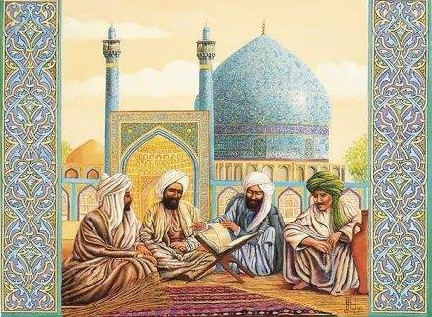
Most of us know about Greek and Roman civilization and the contributions of the great scholars, Socrates, Aristotle, Ptolemy, Galen and Pythagoras, in such fields as philosophy, astronomy, physics, medicine and mathematics.

However, very few of us have heard of Muslim scientists in the Middle East and Europe (Spain) at the time such as Ibn Rushd, Ibn Sina, Al-Razi, Zaharawi, Ibn Al-Haytham, or Ibn Khaldoon, who made equally significant contributions to science during the Dark ages - between the seventh and 15th centuries.

Several factors led to the downfall of the Roman Empire in Europe at this time. In addition to the Barbarian invasions and the Plague, religious conflicts were significant factors.

When the Romans accepted Christianity as a religion, they discredited all scientific and philosophical knowledge. Anyone who differed from the priests was stigmatized as an infidel, heretic, or atheist and was imprisoned or executed.

They saw scientific, cultural, and political advancements as sinful, and any argument or debate about religious matters contradicted Christian dogma. Europeans lost a great deal of classical heritage due to the burning of the great library of Alexandria in 390 A.D. by Christian fundamentalists.

Conversely, Quranic teachings and the sayings of Muhammad (pbuh) inspired and emphasized knowledge acquisition, resulting in the advanced civilization of Muslims in the Middle Ages. Muslim scholars were intensely curious about the world around them, and their enthusiasm and dedication to pursuing knowledge remained unrivaled until the Renaissance period.

At its peak, about one thousand years ago, the Muslim world made a remarkable contribution to science, astronomy, mathematics and medicine.

Abbasid Khalifas built the legendary "Baitul Hikma" or “House of Wisdom” in Baghdad in 763 AD. It was equivalent to the Royal Colleges of England, established to promote higher learning in the 15th century.

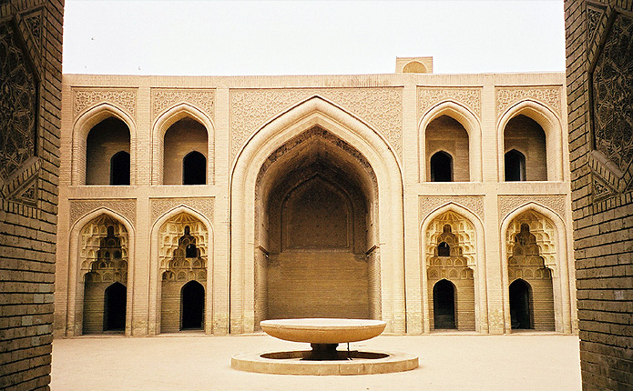

Al-Qarawiyyin University in Fez. Morocco (859), Al-Azhar University of Cairo (970), and Nizamiya College Baghdad (1067) are the oldest universities in the world. It’soften wrongly assumed that they are predated by renowned institutions like Oxford (1167), Cambridge (1209) or Harvard (1636).

These Muslim universities spread the teaching of science, medicine and philosophy from Baghdad to Uzbekistan, Cairo, Iran, Turkey and Spain.

Robert Briffault, in his book "The Making of Humanity," writes, “What we call science arose as a result of the new method of experiment, observation, and measurement, which were introduced into Europe by the Muslims. Science is the most influential contribution of Muslim civilization to the modern world.”

During the Middle Ages, Muslim scholars translated and preserved the works of Greek and Roman philosophers. Europeans accessed their work and 500 years of scientific and philosophical work done by Muslim scholars by translating their work from Arabic to Latin and other European languages.

Many European scholars, including Leonardo da Vinci, Galileo Galilei and Johannes Kepler, were heavily influenced by the works of Muslim scholars such as Ibn Al-Haytham, Ibn Rushd, and Ibn Sina (also known as Avicenna). Their significant contributions to fields such as optics, philosophy, and Medicine had a lasting impact on European intellectual and scientific thought.

During these 800 years, thousands of Muslims in every field of knowledge also played a profound role in developing the European Renaissance by promoting religious tolerance and cultural exchange.

Here are some of these key figures:

Ibn al-Haytham (Alhazen) was a Muslim scientist and philosopher who lived in 10th-century Iraq and Egypt. His most important contribution was that visual perception resulted from light reflecting off objects and entering the eye rather than the eye emitting rays that illuminated things. This theory revolutionized the field of optics and laid the foundation for modern understandings of vision. Europeans translated his work into Latin during the Middle Ages and scholars like Roger Bacon were among the first to introduce Ibn Al-Haytham's ideas to the Western world. Al Haitham's work on optics also influenced Robert Grosseteste, Johannes Kepler, Galileo Galilei and Newton. Ibn Al-Haytham's emphasis on the importance of experimentation and empirical observation, which involved testing hypotheses through investigation and not just philosophical reasoning, helped to establish a scientific methodology. He is regarded as the "first scientist."

Ibn Rush( Averroes) was a Muslim philosopher, jurist, and physician who lived in 12th-century Cordoba, Spain. His writings significantly influenced Western scholars during the Middle Ages and Renaissance. One of Ibn Rushd's most important contributions was his commentary on Aristotle's works, which was preserved and translated into Latin. He documented that Aristotle's philosophy could be reconciled with Islamic theology and demonstrated the compatibility of reason and faith in his commentaries. This approach profoundly impacted European thought during the Middle Ages and Renaissance.

Ibn Tufail, a Muslim philosopher and polymath of the 12th century CORDOBA(Spain),\ wrote "Hayy ibn Yaqdhan," the first philosophical novel pointing out that humans can develop morality without religious education. His ideas significantly influenced European scholars during the Renaissance. The book tells the story of a boy who is abandoned on a deserted island and learns about the world through observation and reason. The novel was translated into Latin in the 17th century. The novel's emphasis on empirical observation influenced scholars like John Locke, who helped shape the course of Western thought and paved the way for the Renaissance.

Al-Zaharawi (Albucasis) was a Muslim surgeon who lived in 10th-century Cordoba, Spain. He is widely considered one of the most influential figures in the history of surgery, and his contributions significantly influenced the development of surgery in Europe. One of Al-Zahrawi's most important contributions was his invention of numerous surgical instruments, including forceps, scalpels, and bone saws. Europeans used the cauterization and suturing techniques developed by Al-Zahrawi to prevent bleeding and promote healing during surgical procedures. They translated his work into Latin during the Middle Ages, where it became known as the "Al-Tasrif." Al-Zahrawi established surgery as a separate specialty; thus, he is called the "Father of surgery." His legacy can still be seen in modern surgical techniques and instruments.

Ibn Sina (Avicenna 980 to 1037), was a physician and a philosopher from Uzbekistan who significantly influenced the Renaissance in Europe. One of Ibn Sina's most important contributions was his masterpiece, "The Canon of Medicine." This was a comprehensive 30-volume encyclopedia of medical knowledge that drew upon the work of Greek, Persian, and Indian physicians. This became one of Europe's most widely used medical textbooks during the Middle Ages and was translated into Latin in the 12th century, remaining in use until the 17th century. Ibn Sina's work on philosophy and logic also presented a comprehensive philosophical system based on Aristotelian and Islamic thought. His book was translated into Latin in the 12th century and became an essential source of knowledge for European scholars as a foundation for the European Renaissance.

Dr. Basheer Ahmed is the former Professor of Psychiatry at Southwestern Medical School and President of the Institute of Medieval and Post-Medieval Studies in North Texas. He can be reached at mbahmed05@yahoo.com.

