Possible Road to Palestine's Independence
BY: BASHEER AHMED SOURCE: Islamicity JUN 5, 2021 NO COMMENTS
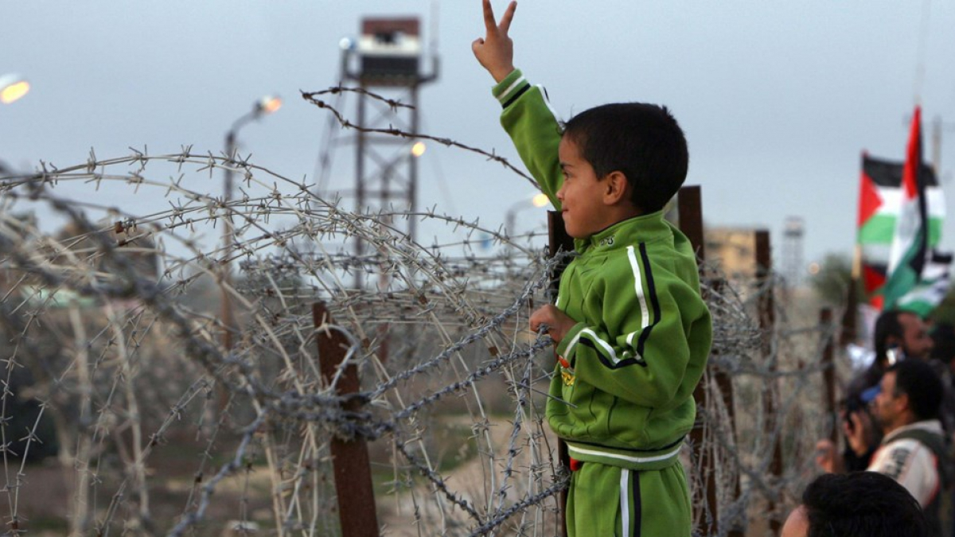
Recent Israeli strikes in Gaza have killed over 250 people, including 80 children, and wounded about 2000, since the end of the holy month of Ramadan. Instead of celebrating Eid festivities, the Palestinians in Gaza mourned their dead.
54 warplanes released 110 rockets and bombs on about 35 targets daily, creating one of the worst humanitarian crises of the century. The battle between Hamas and the Israeli military has damaged 17 hospitals and clinics, destroyed sewage systems, a desalination plant providing water to 250,000 people. Due to persistent bombing, injured people are dying since the ceasefire, due to a lack of medical attention. The humanitarian aid cannot reach Gaza due to the Israeli blockade. The bombing forced some 72,000 Gazans to flee their homes, and 12 Israelis, including a child, killed by rockets from Gaza.
The high civilian death toll and damage to civilian infrastructure have raised questions about Israel's adherence to the international laws of war. Hamas, which has fired more than 3,000 rockets at Israeli cities and towns, and the international community also regards this as violating global war laws.¹
On April 13, the first day of the Muslim holy month of Ramadan, a squad of Israeli police officers entered the Aqsa Mosque in Jerusalem and cut the cables to the loudspeakers that broadcast prayers from four minarets. The Israeli president delivered a speech at the Western Wall, a sacred Jewish site that lies below the mosque, and Israeli officials were concerned that the prayers from loudspeakers would disturb his speech. It was clear that the Israeli police desecrated the prayers at Aqsa Mosque during the holy month of Ramadan. The loudspeaker incident was followed almost immediately by a police decision to close off a popular plaza outside the Damascus Gate, one of the main entrances to the Old City of Jerusalem where young Palestinians typically gather at night during Ramadan.²
The continuous police raid at Al Aqsa during Ramadan was one of several actions that led, less than a month later, to the resumption of war between Israel and Hamas.
The other significant incidents were related to the ongoing Israeli policy to evict Palestinians from their homes and give their property to Jewish settlers. Palestinians regard this as ethnic cleansing. The right-wing Israeli Jews are claiming this as their right to ensure Jewish control over East Jerusalem. A short video confirmed that Jews could walk into Palestinian homes and usurp them as a matter of birthright by saying that Palestinians do not choose; they must give up their lands to the settlers. The Palestinians are blamed for the violence by pointing out that Hamas fired those rockets in the first place. Israel claims the right to defend itself but at the same time does not grant this same right to Palestinians.
Thomas Friedman of the New York times alerted that Israeli Prime Minister Netanyahu was looking for an excuse of war to hold on to his power. "In the wake of Israel's fourth election, and Netanyahu's failure to form a government, an unprecedented national unity coalition was taking shape in Israel — under the leadership of the secular-centrist Yair Lapid and the religious-rightist Naftali Bennett. They were on the verge of forging a cabinet that would include both Israeli Jews and, for the first time, an Israeli Arab Islamist party. That gave the emerging opposition national unity coalition an opportunity to put together a broad government that for the first time would have included right-wing pro-settler Zionist parties, left-wing secular progressive parties, and a pro-Islamist Israeli Arab party. It would have broken the mold of Israeli politics forever. Netanyahu was desperate to stay in power and avoid possibly going to prison if convicted in his current corruption trial."³
Jews and Muslims have been coexisting in the region since the beginning of Islam in the seventh century. The Israel-Palestine conflict is a very modern phenomenon beginning in 1948. Thousands of Jews left Europe to escape persecution and establish a homeland in Israel, Palestine (under the Ottoman empire until 1920). In 1917, Britain issued its famous Balfour Declaration promising the Jews a homeland in British-controlled Palestine. The Holocaust galvanized global public opinion in support of Jews and accelerated Jewish immigration to Israel. In 1947 the UN proposed splitting the land into a state for Jews (Israel) and Arabs (Palestine).
Regional Arab leaders saw the plan as European colonial theft and invaded to keep Palestine unified. The Israeli forces won, and the ethnic cleansing started under the Israeli Zionist regime, which uprooted and expelled entire Palestinian communities, creating about 700,000 refugees.⁴
In 1967, Israel fought another war with its neighbors, during which it militarily occupied the West Bank and Gaza. Today, the West Bank is under Israelis, and Gaza is independent but under military blockade. Israel became an apartheid regime that expelled most Palestinians and treated the remaining 6 million Palestinians as second-class citizens, denying entry to their towns and illegally encroaching onto their houses and property. Palestinians often have no access to the city of Jerusalem for prayers in the Al-Aqsa mosque.
Most Palestinians want fair treatment and an end to the Israeli occupation of the Palestinian territories. They also wish Palestinian refugees and their descendants to return to their former homes in Israel. Palestinians see Israeli settlements in the West Bank grow and believe that Israelis want to make the occupation permanent. Palestinians do not believe that Israelis will allow them a state. Netanyahu has used American cover to expand settlements and pretty much has destroyed any hope of a two-state solution.
By launching rockets and other attacks at Israelis, Hamas has not offered a solution to the issue. Rockets fired by Hamas are not enough to negate the systematic violence that the Palestinians have been experiencing through the decades. Since Hamas took over Gaza in 2006, Israel has invaded or launched extended bombing campaigns in Gaza every few years, destroying the infrastructure and killing hundreds of people. It still did not solve any problems. Hamas arose to counter Fatah with the alleged help of Israel. It was difficult for Israel to fight Fatah (a secular faction within the PLO led by Arafat) morally. Under Hamas's control, the killing of Palestinians did not stop. Fatah has a long record of corruption and mismanagement, which were the significant factors that helped Hamas win parliamentary elections in 2006. Since then, Abbas' approach to his political opponents has been to suspend elections and persecute his rivals.
The Solution:
For the last 73 years, we are seeing the same repeated reactions of Muslims facing oppression.
1)Pray to God to relieve the suffering.
2) Protests are organized in most parts of the Muslim world to register their grievances against oppressors
3) Boycott purchasing goods from countries where Muslims live under oppression.
4) In western countries, various organizations mobilize Muslims to contact their elected officials to intervene.
5) Very seldom do they contact the Muslim kings, dictators, or heads of states as they are aware of their apathy or powerlessness. There is no unity, and we never see a joint effort by Muslim leaders to act against their oppressors.
6)The oppressed people get highly frustrated with prolonged suffering, and they do not see the light at the end of the tunnel, and some turn to terrorism and sacrifice their own lives. They lose their lives without achieving any success except sympathy.
These reactions did not produce any positive results; Palestinians continue to suffer high casualties, lose more land, and suffer more humiliation.
The Palestine Problem is one of the most challenging problems of recent global history. The core issues to the conflict are:
1) Israeli withdrawal from occupied territories,
2) Israeli acknowledgment of a Palestinian state and self-governance,
3) Arab nations acceptance of Israel's right to exist,
4) the right of return by Palestinian refugees.
Every time violence between the Israelis and Palestinians erupts, governments worldwide urge de-escalation, and then a cease-fire agreement is reached. It has been a pattern and, if repeated, the problem will not get solved until Palestinians lose all the territory and leave their country forever.
Israel has built a modern economy that excels in computer-aided products, aviation, nuclear, and biotechnology. Israel has made these achievements by obtaining the highest education, hard work, and working together instead of separating into factions. However, a technologically advanced Israel does not have a right to steal Palestinian land, kill its people, and create the most prolonged, brutal occupation in modern history to satisfy the dream of building Greater Israel.
The US provides Israel with billions of dollars in military and financial support, but Israel does not care about pressure from the US to resolve the Israel-Palestine conflict. Israel defies the US by doing the opposite⁵.
There is no difference between Obama, Trump, or Biden's policies regarding Israel. It is the first time US legislators are questioning the $3.8 billion a year in military assistance the US provides to a highly technologically developed rich country like Israel!
The US should not be a hypocrite and talk about human rights while supporting the Israeli apartheid state with billions of dollars.
Israel does not have any incentive to make a deal with the Palestinians. The Hamas missiles do not inflict much damage on the country due to creating the Iron Dome air-defense system. Israel should not be able to fool western powers that they have the right to protect themselves. They are well protected; they do not have to destroy Gaza.
Most people understand the frustration of people in Gaza, an independent territory of Palestinians surrounded by hostile Israelis who restricted trade, transportation, and all movements, which make Palestinians feel like living in prison. When Palestinians see the escalation in atrocities, they get frustrated and send over 3,000 missiles which killed 12 people and cause some fear in residents. The iron dome prevented all these missiles from reaching the ground. Israelis then saw this as an excuse to defend themselves and bombed Gaza indiscriminately, killing hundreds of people, including women and children, destroying residential buildings, and infrastructure. These recent attacks displaced 70,000 residents and left them with nowhere to go. Who is suffering more and why? It is the third time the people of Gaza sustained these atrocities without achieving any positive results except sympathy and revitalizing the Palestinian issue and bringing it to the world’s attention.
Immediate short-term solutions:
Protests are necessary to disseminate correct information about oppressors and to gain public support. I strongly recommend engaging all sects of Muslims and non-Muslims to show strong support. Engage elected officials to support the cause. For the first time in history, US Senator Bernie Sanders and Jon Ossoff (both Jewish) and Congresspersons Rashida Talib, Ilhan Omar, Cori Bush, Ayanna Presley, Andre Carson, and Alexandria Ocasio-Cortez spoke emotionally and eloquently about Israel's apartheid policies. It influenced to cause an immediate cease-fire and the further destruction and loss of Palestinian lives.
The protests must continue as a MOVEMENT until justice and liberation of Palestinian people are achieved. We have protested umpteenth times, achieving cease-fires and momentary peace. It is time to change protests into a MOVEMENT. It will help defeat Israel's apartheid regime just as a united African people's movement defeated South Africa's apartheid regime. The protest movements last summer in the US made young people, including Jews, understand racism more explicitly. It makes them aware of the nature of the Israel/ Palestine situation and realizes it is the same system.⁶ This is a good opportunity to engage young people in the US by providing vital information about the Israeli-Palestinian conflict and engaging them worldwide. Supporters of Israel should realize that it's not anti-Semitic to criticize Israel for possible apartheid policies and war crimes. Long term solution:
United Palestinian Movement
Palestinians must have a strong leader assisted by an efficient and dedicated team. It must control the ego and resist forces luring to their corruption and division. Without solid Palestinian leadership, the independence movement will not be successful. Palestinians must depend on themselves with self-confidence, build positive relationships with all countries supporting their cause, change worldwide opinion without making ineffective threats, and develop strategic planning to succeed. Anger and emotional reactions will not lead to any success. Self-reliance cannot be achieved until they excel in science and technology and focus on industrial development. Give young people the opportunity to excel in science and technology as the Koreans, Japanese, and Chinese did when they gained their independence. They were in the same shape as Palestinians when they broke the shackles of colonialism. Muslims were at the forefront of all fields of science and technology for 1,000 years. Their decline started due to the lack of education. The independent Palestinian state requires Islamic ethics and morals, not like the current Islamic States built on corruption, dishonesty, and dictatorship, and then develop into an industrial state like Taiwan, Korea, or Singapore.
Palestinians must not depend on Muslim countries or Non-Muslim Western powers to rescue them. Receive aid initially for 5-10 years or longer for education and then build institutions for higher learning to free themselves from dependency on others.
Our prayers for 70 years have not produced any results because Allah has stated clearly in Quran:"… God does not change the condition of a people unless they change themselves…" (13:11). We need to follow Allah's commandments with a deep understanding of the Quran, which directs Muslims to learn, reflect, and ponder upon life and the universe around us.
Palestinians must have a dream, need to work hard to actualize it, and then Allah will help.
Footnotes:
1) Declan Walsh "When Fighting Erupts Between Israel and Hamas, the Question of War Crimes Follows" N Y Times May 16, 2021
2) Patrick Kingsley "After Years of Quiet, Israeli-Palestinian Conflict Exploded. Why Now?" New York Times May 17, 2021
3) THOMAS L. FRIEDMAN "For Trump, Hamas, and Bibi, It Is Always January 6" New York Times May 16, 2021
4) Zack Beauchamp "What is the Nakba?" VOX May 14, 2018
5) Zack Beauchamp "Obama and Netanyahu hate each other. But don't expect America to turn on Israel." Vox October 28, 2014,
6 ) Elizabeth Dias and Ruth Graham "The Gaza Conflict Is Stoking an 'Identity Crisis' for Some Young American Jews" N Y Times May 19, 2021
Dr. Basheer Ahmed is the former professor of psychiatry, South Western Medical School, Dallas, Texas, and chairman emeritus MCC for Human services North Texas. He Can be reached at mbahmed05@yahoo.com

